Lab-5: Ethical Foundations – Responsible AI Coding Practices

Name:V.Prapul Kumar
Roll no:2503A52377
Batch-13
Task Description #1 (Privacy in API Usage)
Task: Use an AI tool to generate a Python program that connects to a weather API.
Prompt:
"Generate code to fetch weather data securely without exposing API keys in the code."
Original AI-generated code
import requests

city = "Hyderabad"
api_key = "YOUR_API_KEY"

url = f"https://api.openweathermap.org/data/2.5/weather?q={city}&appid={api_key}&units=metric"

response = requests.get(url)

if response.status_code == 200:
data = response.json()
print("City:", data["name"])
print("Temperature:", data["main"]["temp"], "°C")
print("Weather:", data["weather"][0]["description"])
else:
print("Unable to fetch weather data.")
Secure version using environment variables:
import os
import requests

city = "Hyderabad"
api_key = os.getenv("WEATHER_API_KEY")

if not api_key:
print("API key not found.")
else:
url = f"https://api.openweathermap.org/data/2.5/weather?q={city}&appid={api_key}&units=metric"

response = requests.get(url)

if response.status_code == 200:
data = response.json()
print("City:", data["name"])
print("Temperature:", data["main"]["temp"], "°C")
print("Weather:", data["weather"][0]["description"])
else:

print("Unable to fetch weather data.")
Output:
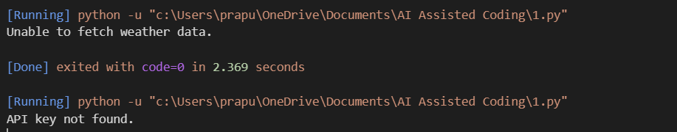

Comparision:
Original Version | Secure Version
API key is written directly in the code. | API key is stored in an environment variable.
Key can be exposed if the code is shared or uploaded. | Key is not visible in the source code.
Less secure for real applications. | More secure and suitable for real applications.
Task Description #2 (Privacy & Security in File Handling)
Task: Use an AI tool to generate a Python script that stores user data (name, email, password) in a file.

Prompt:
Generate a beginner-friendly Python program that stores a user's name, email, and password in a file. Keep the code simple and include basic comments.
Original AI-generated code:
name = input("Enter your name: ")
email = input("Enter your email: ")
password = input("Enter your password: ")

with open("user_data.txt", "w") as file:
file.write("Name: " + name + "\n")
file.write("Email: " + email + "\n")
file.write("Password: " + password + "\n")

print("User data saved successfully.")

Revised secure version — password hashing:
import hashlib

name = input("Enter your name: ")
email = input("Enter your email: ")
password = input("Enter your password: ")

hashed_password = hashlib.sha256(password.encode()).hexdigest()

with open("user_data.txt", "w") as file:
file.write("Name: " + name + "\n")
file.write("Email: " + email + "\n")
file.write("Password Hash: " + hashed_password + "\n")

print("User data saved securely.")
Output:
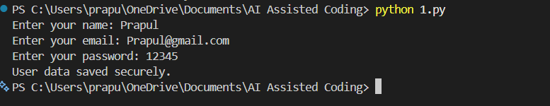

Comparision:
Original Version | Revised Secure Version
Stores the password in plain text. | Stores a hashed password instead.
Anyone accessing the file can read the password. | The original password is not directly visible.
Sensitive data is not protected. | Password storage is more secure.
Risk of password exposure is high. | Risk of direct password exposure is reduced.
Not suitable for real applications. | Safer approach for password storage.
Task Description #3 (Transparency in Algorithm Design)
Objective: Use AI to generate an Armstrong number checking function with comments and explanations.

Prompt:
Generate a beginner-friendly Python function to check whether a number is an Armstrong number. Add clear comments explaining each step.

Code:
def is_armstrong(number):
# Store the original number for comparison later
original = number

# Find the number of digits
digits = len(str(number))

# Start the sum at zero
total = 0

# Process each digit of the number
while number > 0:
digit = number % 10

# Add the digit raised to the number of digits
total += digit ** digits

# Remove the last digit
number //= 10

# Check whether the calculated sum equals the original number
return total == original

# Test the function
number = 153

if is_armstrong(number):
print(number, "is an Armstrong number.")
else:
print(number, "is not an Armstrong number.")

Output:

Justification:
The program correctly checks whether a number is an Armstrong number. The comments explain each step, including finding the number of digits, extracting each digit, calculating its power, and comparing the total with the original number. The explanation matches the actual functionality of the code, making the algorithm transparent and easy to understand.
Task Description #4 (Transparency in Algorithm Comparison)
Task: Use AI to implement two sorting algorithms (e.g., QuickSort and BubbleSort).
Prompt:
"Generate Python code for QuickSort and BubbleSort, and include comments explaining step-by-step how each works and where they differ."

Code:
# QuickSort
def quick_sort(numbers):
# If the list has 0 or 1 element, it is already sorted
if len(numbers) <= 1:
return numbers

# Select the last element as the pivot
pivot = numbers[-1]

# Store elements smaller than or equal to the pivot
smaller = [x for x in numbers[:-1] if x <= pivot]

# Store elements greater than the pivot
greater = [x for x in numbers[:-1] if x > pivot]

# Recursively sort both parts and combine them
return quick_sort(smaller) + [pivot] + quick_sort(greater)

# BubbleSort
def bubble_sort(numbers):
# Create a copy so the original list is not changed
numbers = numbers.copy()

# Compare adjacent elements repeatedly
for i in range(len(numbers)):
for j in range(len(numbers) - i - 1):

# Swap if the elements are in the wrong order
if numbers[j] > numbers[j + 1]:
numbers[j], numbers[j + 1] = numbers[j + 1], numbers[j]

return numbers

# Test data
values = [64, 34, 25, 12, 22, 11, 90]

print("Original list:", values)
print("QuickSort:", quick_sort(values))
print("BubbleSort:", bubble_sort(values))

Output:
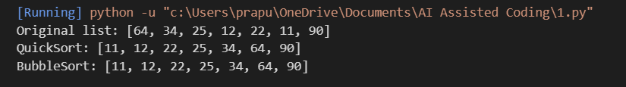

Justification:
The program implements both QuickSort and BubbleSort correctly and produces the same sorted result for the given input. The comments explain the main steps of each algorithm, making their logic transparent. QuickSort uses a pivot and recursively divides the list, while BubbleSort repeatedly compares adjacent elements and swaps them. QuickSort is generally more efficient on average, while BubbleSort is simpler but has higher time complexity for larger lists.
Task Description #5 (Transparency in AI Recommendations)
Task: Use AI to create a product recommendation system.
Prompt:
"Generate a recommendation system that also provides reasons for each suggestion."

Code:
# Product recommendation system

products = [
{"name": "Laptop", "category": "Electronics", "price": 55000},
{"name": "Headphones", "category": "Electronics", "price": 3000},
{"name": "Running Shoes", "category": "Sports", "price": 2500},
{"name": "Smart Watch", "category": "Electronics", "price": 7000}
]

# Recommend products based on the user's preferred category
def recommend_products(category, budget):
recommendations = []

for product in products:
# Check whether the product matches the category and budget
if product["category"] == category and product["price"] <= budget:

# Give a reason for recommending the product
reason = (
"Recommended because it matches your preferred "
"category and is within your budget."
)

recommendations.append((product["name"], reason))

return recommendations

# Test the recommendation system
category = "Electronics"
budget = 10000

results = recommend_products(category, budget)

if results:
print("Recommended Products:")

for product, reason in results:
print("\nProduct:", product)
print("Reason:", reason)
else:
print("No suitable products found.")
Output:
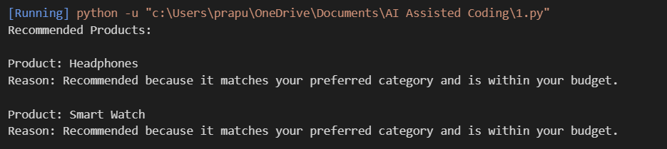

Justification:
The program provides product recommendations based on the user’s preferred category and budget. Each recommendation includes a clear reason explaining why the product was suggested. This makes the recommendation process transparent and easy for the user to understand rather than giving unexplained results.

